Copy No………of 20

JRCN/J5/5-01

A JOINT MILITARY APPRECIATION ON OP FOX KILLER

For: Laksdya Dato’ Aris Adi Tan bin Abdullah Fmn/Unit: Joint Regional
Commander North HQ

By: JOPG Fmn/Unit: JRCN HQ

At: JRCN HQ Lumut On: 071800H Oct 2019

Ref:

A. MKN.(R)8.600-4/2 JLD dated 1 Aug 19.
B. Initiating Directive (ID) of EKS PAHLAWAN dated 17 Sep 19.
C. MATM/BPP-STGK/600-26 dated 13 Sep 19.

Time Zone Used Throughout the Appr: HOTEL

STEP 1 – SCOPING AND FRAMING

SUBSTEP 1 – SCOPING

1. Commander’s Initial Guidance. After studying carefully, the Initiating Directive (ID) from CDF, the co-responding JRCN guidance and Commander Critical Information Requirement (CCIR) are as follow:

- PIR.

- Location of MUSANGLAND Reserve.
- MUSANGLAND Forces forward log base.
- CHILAND asset involved in this crisis.
- UN security council resolution on MUSFOR invasion.
- Local MUSANGLAND citizen support level of MUSFOR
operations.

- International/local media perception on MALFOR operations.
- FFIR.

- Availability of FPDA forces.
- PDRM activity in curbing TEDUNG activity.
- Cabinet approval in conducting attk in MU territory.
- The status of Northern Perak.
- EEFI.

(1) Preparation and deployment to FMB of RDF.
(2) ISR activity.
(3) OPSEC.
(4) Subversive Ops.
(5) IO asset and activity.
d. Risks.

- Risk Threshold. As table below.

Risk Index | Risk Level | Endorsing/Approval Authority
13 – 25 | High | CDF
8 – 12 | Significant | JRCN
4 – 7 | Moderate | Component Commander
1 – 3 | Low | Joint Task Group

- Risk Given. After referring to preliminary planning guidance, the
initial risks given are as follow:

- No border crossing to MUSANGLAND and others regional territories without Cabinet approval.

- Obey all current treaties, domestic and international laws.

- All military activity is to follows issued ROE.

- NATPOL B must be adhered.

- Summary of Current Situation.

- Tedung Gp. Tedung personnel been deployed to conduct
sabotage attk toward MAL and been captured with Photo of MAL valuable target. Assess Tedung Gp members have been disperse around Northern MAL to spread the ideology and conduct sabotage.

(2) MUSANGLAND AF. The latest intelligence reports indicate aggressive intrusion of MUSANGLAND special forces, land, maritime and air assets into MAL. Disruption to the maritime community and JDA. Cyber-attacks and hacking attempts over MAL secured networks.
(3) Intervention. Strategic estimates indicate that the United Nations (UN) and ASEAN remain on a neutral basis and propose for peace negotiation.

2. Previous Planning Activities. None.

3. Planning and Operational Timelines.

a. Planning Timeline.

Receipt of ID Decision and Execution

CONOP Dev

17 Sep 19 7 Oct 19 17 Nov 19

Planning Ratio ⅓ ⅔

b. Operational Timeline.

D day Redeployment

17 Nov 19 17 May 20 (UFN)

180 days ops duration

4. Force Preparation and Capabilities. As per JIPOE Step 3.

SUBSTEP 2 – FRAMING

5. Environment Frame.

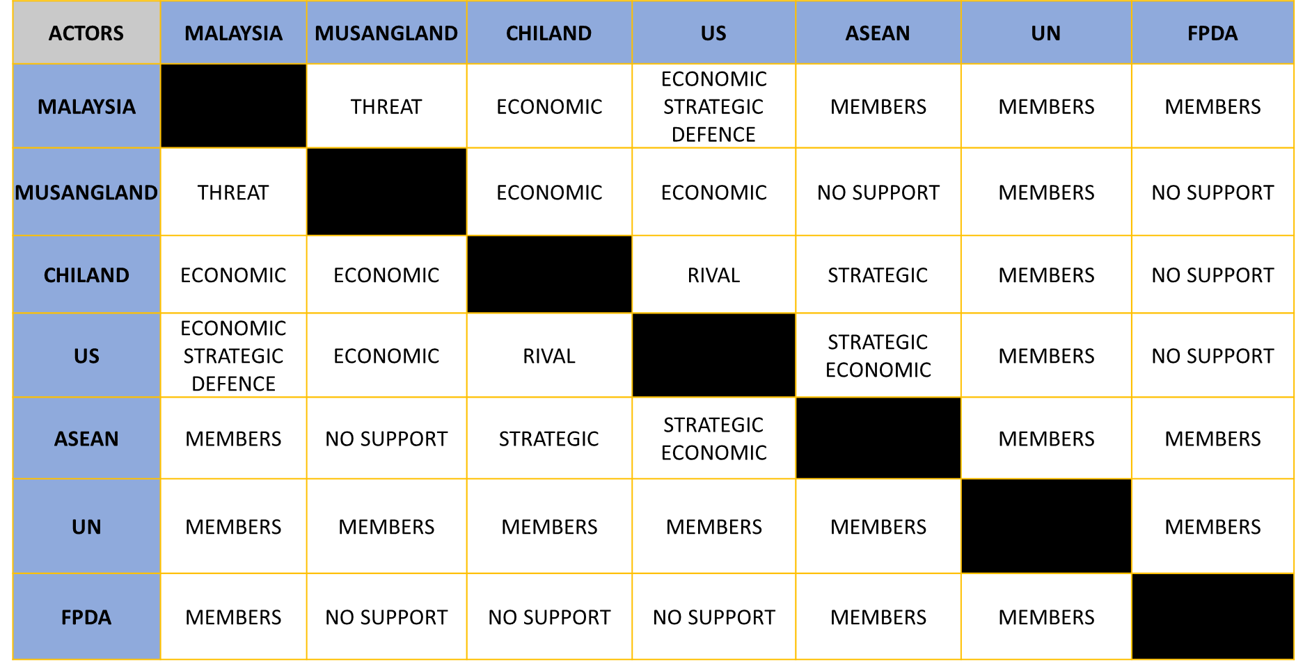

Observed System

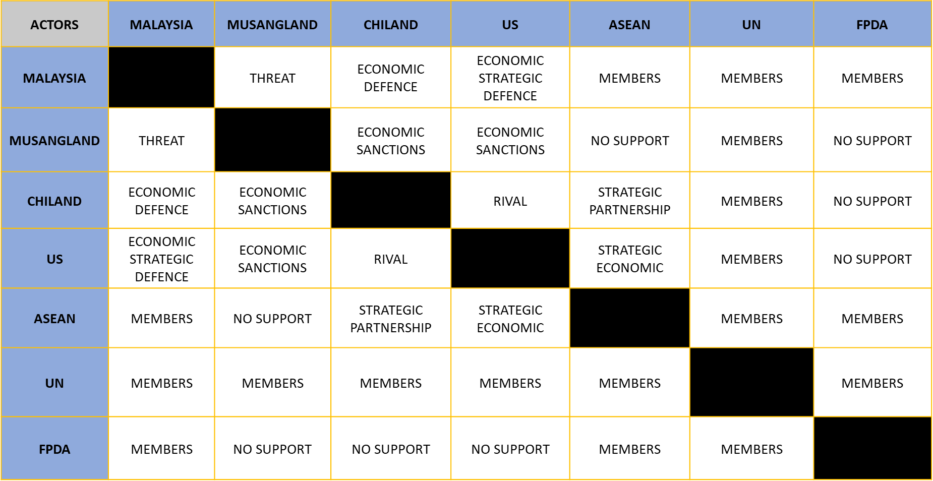
MAL

Desired System

6. Problem Frame.

- Problem Analysis.

ISSUE | MITIGATION | LIKELY OUTCOMES | PROBLEM
(a) | (b) | (c) | (d)
Strained relation bet MALAYSIA and MUSANG LAND due to overlapping claims of land territory. | MALAYSIA need to enhance the diplomatic relationship with International, regional partners and ASEAN members so as to support Malaysia’s claims. | Neighbouring countries unlikely to interfere. UN will agree to Malaysia’s rights as stated in BANDIDA Agreement. | - Overlapping issue  will be prolonged.  - Mil activities will  make the sit escalate.
TEDUNG elm infiltrate to MAL territory to gain influence and supporter | - Dissemination of  propaganda to win heart and mind of population  2. Prevent integration of TEDUNG’s ideology into local people by counter propaganda  3. Deny accessibility TEDUNG infiltration to Malaysia | 1. TEDUNG group to lose popularity in Malaysia  - TEDUNG  recruitment plan failed  - Local people  refuse to support TEDUNG campaign | TEDUNG’s radical ideologies will be difficult to curb by using mil action.
The MALAYSIA Government is ultimately concerned with the sovereignty of Perlis, Kedah, Kelantan and Terengganu. | - Use of force to  defend territory.  - Use of IO to  reduce MU AF capability and support. | Northern territory preserved. | - The use of mil action  is needed.  - MU AF must be  defeated.  - Potential international  instability and backlash.

(a) | (b) | (c) | (d)
Cyber attacks against Malaysia by suspected MUSANGLAND Element. | 1.MAF cyber capabilities and readiness will be increased for further attack will be neutralised.  2. MCMC to increace readiness and analysis protocols to identify and neutralise attacks.  3. To use foreign and local expertise to strengthen data and communcation environment. | Cyber attk by MU AF contained. | If fail, this will be disrupted the economic, financial and social activities for Rakyat Malaysia.
Instability of internal political, sy and economic unrest in MALAYSIA. | MALAYSIA have to improve readiness to deploy force from any threat.  UN NGO agencies and Medical NGO will be activated and ready to help the people. | Prolonged strained scenario will occur.  Increase refugees and IDP into Malaysia. | Malaysia does not want refugees and IDP.  International investment will deteriorte and leave the region.  Increase of transnational crime along the boarders.
Maritime dispute on fisheries activity especially in JDA. | 1. Enforcing coastal fishing areas.  2. Securing SLOC at SCS and SoM.  3. All security agencies will be deployed to ensure safety of the fishermen. | Disruption to maritime community and fishing activity along the SoM and SCS. | The people will lose trust in the Govt.  The maritime people will lose their livelyhood.  Govt will lose look weak and trust in the capabilities will deteriorate.
Cyber attack by suspected MUSANGLAND Threat Actor on Malaysia CNII. | Malaysia CNII to be strengthened. Main network and application to be continuously monitored. | CNII, main network and application successfully defended.  MUSANGLAND efforts to degrade our CNII denied. | Disruption of government administration mechanism, C2 of defence and security agencies, economic, financial and social activities.
- Problem Narrative. Territorial dispute between MAL and
MUSANGLAND will be prolonged even though continuous diplomatic effort being carried out. Therefore, to defend against MUSANGLAND assertion on Northern Territory militarily is required. However, due to legal restriction, MAL only can defend based on self-defence basis. Furthermore, enduring operation in restoring and stabilising the AO may be required aftermath of crisis.

SUBSTEP 3 – DETERMINE THE DESIRED CAMPAIGN OR OPERATION ENDSTATE

7. Determine Desired Endstate.

a. Strategic Military Endstate. MUSANGLAND AF invasion into Northern Malaysia is denied. Malaysia’s sovereignty is preserved.

b. Desired Operational Endstate. MUSANGLAND AF is defeated and TEDUNG Group neutralised. Sovereignty over Northern Malaysia preserved. To conduct Stab Ops until Status Quo Ante is achieved.

SUBSTEP 4 – DEVELOP AND ISSUE WARNING ORDER

8. Develop and Issue WngO.

ONE. MAL DEF TO DENY MUSANG LAND ACCESS TO MALAYSIAN TERRITORY.

TWO. NO MOV BEFORE D-30.

THREE. OGP AT PRESENT JRCN HQ LOC AT 170900H OCT 19.

FOUR. INTEL COLLECTION PLAN TO BE ACTIVATED BY D-30.

FIVE. LOG ELM TO PLAN AND PROVIDE LOG SP FOR THE OP ESTIMATE TO 45 DAYS.

ACK

STEP 2 – MISSION ANALYSIS

SUBSTEP 1 – REVIEW OF THE SIT

8. Review Latest Commander’s Guidance and Intelligence Information. No changes as per Step 1.

9. Review Output of Scoping and Framing. No changes as per Step 1.

10. Refine Lesson Learned from Previous Operations. No changes as per Step 1.

SUBSTEP 2 – DERIVE AND ANALYSIS CENTRES OF GRAVITY
11. Own COG and Critical Factors Analysis.

MUSANGLAND AF is defeated and TEDUNG group neutralised. Sovereignty over Northern Malaysia preserved. To conduct Stab Ops until Status Quo Ante is achieved

COG | CC | CR | CV
(a) | (b) | (c) | (d)
JRC N | Ability to secure ALOC | Fighter AC  Transport AC  Helicopter  AD Radar  C2 | POL, AB, Ammo, Pers, Comm, Rat
JRC N | Ability to secure SLOC | Frigate  Corvette  SSK  Super Lynx  B200T | POL, Port, Pers, Ammo, Comm, Radar, Rat
JRC N | Ability to hold gnd | Infantry  Arty | POL, Ammo, Comm, Pers, Rat
JRC N | Ability to sustained Log Sp | Main Supply Route  Airlift  Medical | POL, Comm, Pers, Fwd hospital, Port, AB, Road,
JRC N | Ability to Search and Destroy  (Tedung Gp) | Infantry  Arty  SOF  EC-725 | POL, AB, Ammo, Pers, Port, Comm, Rat
JRC N | Ability to protect National Key Installation | Infantry  Arty  Fighter AC  Frigate  Corvette  GBAD | POL, AB, Ammo, Pers, Port, Comm, Rat
JRC N | Ability to conduct IO | HUMINT / PSYOP  Cyber app & sys  ESM  OSINT  Broadcasting  CNII | COMINT asset, ELINT asset, Comm tower, Key Personal, Power Grid, Broadcasting tower, Line Cable, Submarine Cable landing site
(a) | (b) | (c) | (d)
 | Ability to gain support OGD/NGO | Media Agency  Cyber platform  HUMINT/PsyOps  OSINT | Comm tower, Key personnel, power grid, broadcasting tower, line cable, submarine cable landing site
Deduction | Based on data provided above, all logistic support must be protected iot achieve the mission and to sustain the operation upon completion.

SUBSTEP 3 – DETERMINE OWN MISSION

12. Analyse Superior Commander’s Intent.

- Purpose. To defend Malaysian sovereignty from MUSANGLAND
AF invasion and TEDUNG Group subversive activities.

- Method. To gain air, sea and land parity through mil op to prevent
MUSANGLAND invasion and TEDUNG Group subversive activities.

c. End State. MUSANGLAND AF invasion and TEDUNG Group subversive activities defeated. Northern Malaysia region sovereignty secured.

13. Develop Own Mission. JRC NORTH is to defend Northern Region Malaysia (Kedah, Perlis, Kelantan & Terengganu) NLT 17th Nov 19 iot maintain Malaysia sovereignty against MUSANGLAND invasion and TEDUNG GP subversive activities.

SUBSTEP 4 – DETERMINE OBJECTIVES

14. Operational Objectives. Based on the Operational Desired Endstate, the operational objectives derived are as follow:

- Objective 1. MUSANGLAND defeated.

- Objective 2. Tedung Group neutralised.

- Objective 3. Local support gained.

- Objective 4. Stabilisation Op within Northern Malaysia established.

SUBSTEP 5 – IDENTIFY AND ANALYSIS TASKS

15. Tasks Analysis.

Specified Tasks | Implied Tasks
(a) | (b)
1. Show of Present on land, maritime and air.  2. To shape the perception of Malaysian and MUSANGLAND including the International Community.  3. To cooperate with FPDA member state military assets as they are mobilized to assist Malaysia.  4. To conduct framework operation in Northern Malaysia to cripple/disrupt the communication network of MUSANGLAND and TEDUNG Group. | 1. MU AF ISR denied.  2. Local Air superiority established.  3. Airport n Seaport secured.  4. MU AF invade into Northern Malaysia denied.  5. Tedung Group financial & log support disrupted.  6. Tedung Group cells destabilized.  7. Local govt restored.  8. MUSANGLAND AF defeated.  9. Key Leadership personnel protected.  10. Tedung Group ideology disrupted.  11. MUSANGLAND psyop/media propaganda countered.  12. MUSANGLAND SLOC denied.  13. MUSANGLAND ALOC denied.  14. Prevent humanitarian crisis.  15. Rebuild community.  16. Public service restored.  17. Public Infra restored.  18. Citizen trust gained.  19. Local support regained.  20. JRCN Redeployed.  21. Key installation protected.  22. Territory defended.  23. Enemy Key Installation destroyed. NLT D Day.
(a) | (b)
24. MUSANGLAND IO effectiveness denied NLT D – 15.
25. MUSANGLAND C2 distrupted NLT D Day
26. CNII within Northern corridor protected from MUSANGLAND threats and exploitation NLT D – 2.
27. Local population in the SOUTHERN MUSANGLAND influenced against MUSANGLAND and supported MALAYSIA NLT D – 30.
28. Patriotism amongst MALAYSIAN maintained and enhanced NLT D-20.
29. TEDUNG Group subversive and espionage activities denied NLT D-30.
30. Regional and international communities support obtained NLT D-Day.
30. FIR and ADIZ declared D+1.

* Those BOLD statement are selected Essential Tasks (ET).

SUBSTEP 6 – DETERMINE LIMITATIONS

16. Restrictions and Constraints.

Restrictions | Constraints
(a) | (b)
1. No border crossing to MUSANGLAND and others regional territories.  2. Obey all current treaties, domestic and international laws.  3. All military activity is to followed issue ROE. | 1. Casualties are to be kept to a minimum.
(a) | (b)
4. Any military action must get approval from NSC.  5. NATPOL B must be adhered. | 2. Minimise collateral damage.

SUBSTEP 7 – IDENTIFY CRITICAL FACTS AND ASSUMPTIONS

17. Critical Facts.

a. High density of SLOC in Gulf of Thailand and Straits of Malacca.
b. Both countries have promulgated FIR and ADIZ areas.
c. Monsoon season during operation.
d. Captured MU AF will be handled as POW’s.
e. Captured Tedung Gp personnel will be handled according to domestic laws.

18. Assumptions.

a. CHILAND will support and assist MUSANGLAND.
b. UNSCR on MU AF invasion.
c. PDRM and Security agencies will disrupt Tedung group activities.
d. It is believe that US will support Malaysia.
e. Support from FPDA and ASEAN might be gained by Malaysia.
f. Cabinet approval derived in conducting cross border establish on MUSANGLAND.

g. All RFI’s for additional assets are granted.

SUBSTEP 8 – DETERMINE DECISIVE POINTS (DPs)

19. List of DPs. All possible DPs are as per listed below. Detailed DPs matrix is at Annex A.

DP | Remarks
(a) | (b)
DP 1 - MU AF invade into Northern Malaysia denied on D Day  DP 2 - MUSANGLAND ALOC denied NLT D+3  DP 3 - MUSANGLAND SLOC denied NLT D+3  DP 4 - Local Air superiority established NLT D Day  DP 5 - Airport n Seaport secured NLT D Day  DP 6 - Local govt restored NLT D+90  DP 7 - MU AF defeated NLT D+45  DP 8 - Tedung Group cells destabilized NLT D Day  DP 9 - Key Leadership personnel protected NLT D-20  DP 10 - Tedung Group ideology disrupted NLT D+45  DP 11 - MUSANGLAND psyop/media propaganda countered NLT D-20  DP 12 - Humanitarian crisis prevented NLT D+70  DP 13 - Public service restored NLT D+90  DP 14 - Public Infra restored NLT D+90  DP 15 - Local sp regained NLT D-5  DP 16 - JRCN Redeployed NLT D+9  DP 17 - Key installation protected NLT D Day  DP 18 - MU AF ISR disrupted NLT D-20  DP 19 - Territory defended NLT D Day  DP 20 - Enemy Key Installation destroyed NLT D Day  DP 21 - MUSANGLAND IO effectiveness denied NLT D - 15  DP 22 - MUSANGLAND C2 distrupted NLT D Day  DP 23 - CNII within Northern corridor protected from MUSANGLAND threats and exploitation NLT D - 2  DP 24 - Local population in the SOUTHERN MUSANGLAND influenced against MUSANGLAND and supported MALAYSIA NLT D - 30  DP 25 - Patriotism amongst MALAYSIAN maintained and enhanced NLT D - 20 | ET  ET  ET  ET  ET  ET  ET and target adversary CV  ET and target adversary CV  ET  ET and protect own CV  ET and protect own CV  ET  ET  ET  ET  ET  ET  ET and protect own CV  ET and protect own CV  ET and target adversary CV  ET and protect own CV  ET and protect own CV  ET and protect own CV  ET  ET
(a) | (b)
DP 26 - TEDUNG Group subversive and espionage activities denied NLT D - 30  DP 27 - Regional and international communities support obtained NLT D Day | ET and protect own CV  ET

SUBSTEP 9 – DEVELOP LINES OF OPERATIONS

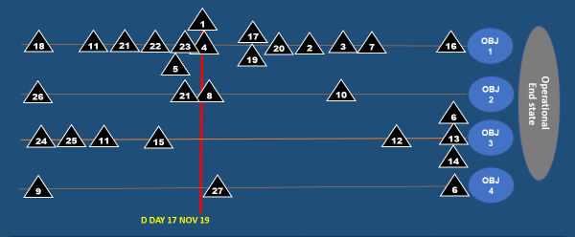
20. Initial LOO Schematic Diagram.

Objectives:
Obj 1: MUSANGLAND defeated | Obj 2:  Tedung Gp neutralised | Obj 3:  Local Support gained | Obj 4:  Stabilization Op within Northern Malaysia established
(a) | (b) | (c) | (d)
DP 18 - MU AF ISR disrupted NLT D-20  DP 11 - MUSANGLAND psyop/media propaganda countered NLT D-20  DP 21 - MUSANGLAND IO effectiveness denied NLT D - 15 | DP 26 - TEDUNG Group subversive and espionage activities denied NLT D - 30  DP 21 - MUSANGLAND IO effectiveness denied NLT D - 15  DP 8 - Tedung Group cells destabilized NLT D Day  DP 10 - Tedung Group ideology | DP 24 - Local population in the SOUTHERN MUSANGLAND influenced against MUSANGLAND and supported MALAYSIA NLT D – 30.  DP 25 - Patriotism amongst MALAYSIAN maintained and | DP 9 - Key Leadership personnel protected NLT D-20  DP 27 - Regional and international communities support obtained NLT D Day  DP 6 – Local govt restored NLT D+90
(a) | (b) | (c) | (d)
DP 22 - MUSANGLAND C2 distrupted NLT D Day.  DP 23 - CNII within Northern corridor protected from MUSANGLAND threats and exploitation NLT D - 2  DP 1 - MU AF invade into Northern Malaysia denied on D Day.  DP 4 - Local Air superiority established NLT D Day  DP 5 - Airport n Seaport secured NLT D Day  DP 17 - Key installation protected NLT D Day  DP 19 - Territory defended NLT D Day.  DP 20 - Enemy Key Installation destroyed NLT D+2.  DP 2 - MUSANGLAND ALOC denied NLT D+3  DP 3 - MUSANGLAND SLOC denied NLT D+4 | disrupted NLT D+45 | enhanced NLT D – 20.  DP 11 - MUSANGLAND psyop/media propaganda countered NLT D-20  DP 15 - Local sp regained NLT D-5  DP 12 - Humanitarian crisis prevented NLT D+70  DP 6 - Local govt restored NLT D+90  DP 13 - Public service restored NLT D+90  DP 14 - Public Infra restored NLT D+90
(a) | (b) | (c) | (d)
DP 7 - MU AF defeated NLT D+45
DP 16 - JRCN Redeployed NLT D+90

STEP 3 – COURSE OF ACTION (COA) DEVELOPMENT

SUBSTEP 1 – REVIEW OF THE COMMANDER’S GUIDANCE AND CURRENT SITUATION

21. No changes.

SUBSTEP 2 – DEVELOP DETAILED COURSES OF ACTION

22. COA 1 (DETER & ISOLATE).

- Intent.

(1) Purpose. To defend Northern Malaysian territory from MU AF invasion and TEDUNG Gp subversive activities.

(2) Method. Enemy forces to be neutralise before invasion. Covert ops to be carried out against TEDUNG Group before MALFOR D-Day. Optimise use of Joint Assets to ensure objective is gain.

(3) Endstate. MU AF is defeated and TEDUNG Gp neutralised. Sovereignty over Northern Malaysia is preserved. Conduct Stab Ops until Status Quo Ante is achieved.

- Scheme of Manoevre (SOM). Deterrent Ops will be conducted by current Ops unit. LC will defend and show of force supported by AC & MC. Conducting ISR. Mech Bde as mob res. Sea blockade by MC. AC to gain Local Air Superiority.

The ops will be conducted in 3 phases:

- Phase 1. Preparation (D-30 to D-1).

- Pre-position troop and assign assets.
- Gaining info about Tedung Group by deploying ISR & Civil
Agency.

- Gaining info about enemy troop by SOF.
- Gaining enemy movement info by deploying AC & MC ISR.
- LC prepares defence position (D – 3).
- FOB to be establish at Lumut & Kuantan Naval Base (D – 14).
- IO conducted to shape the local and International sp.
Positioning of Naval assets (D – 10).

- MC to establish sea blockade (D – 7).
- AC to establish Local Air Superiority (D – DAY).
- Fighters move to Kuantan AB (D – 7).
- Heli move CSAR/SAR (D -5).
- Conduct FIT by all components (D – 21).
- Liaison other security agencies.
- Joint comm network establish. (D – 30)
(o) Sea control & Air superiority. (D-3)
ME. Shaping Op.
SE. Force element preparation. Show of presence.

- Phase 2. Defensive (D day to D+65).

- Continue IO ops to shape the local and International support.

(b) LC disrupt Tedung Group ISR.
(c) Deny MU AF invasion by LC.
(d) MC to secure SLOC.
(e) AC to secure Local Air Superiority.
(f) LC defence position defended (D – Day)
(g) Secure LoC.
(h) Air Ops supporting Land Ops.
(i) FIR and ADIZ declared (D+1).
ME. Defensive Op.
SE. Supporting Op.

- Phase 3. Isolate (D+65 to D+150).

- Disrupt Tedung Group Ideology.
- Restore Local governance.
- Redeploy JRCN forces.
- Restore public and service Infra.
- Avert humanitarian crisis.
- Enhance border security.
- AC & MC to Show of Presence in AO.
ME. Stabilisation Op.
SE. Tedung Group ideology defeated..

- LOO Schematic.
Deter and Isolate

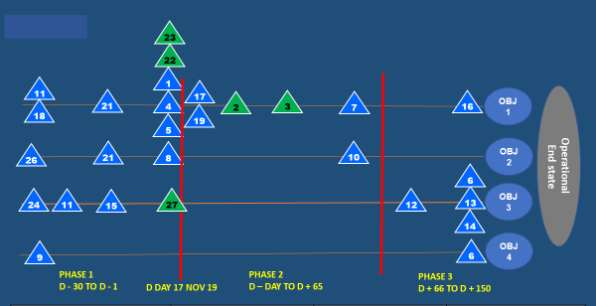

Desired Endstate:
MU AF is defeated and TEDUNG Gp neutralised. Sovereignty over Northern Malaysia is preserved. Conduct Stab Ops until Status Quo Ante is achieved.

Objectives:

(a) | (b) | (c) | (d)
Obj 1: MUSANGLAND defeated | Obj 2:  Tedung Gp neutralised | Obj 3:  Local Support gained | Obj 4:  Stabilization Op within Northern Malaysia established
(a) | (b) | (c) | (d)
DP 18 - MU AF ISR disrupted NLT D-20  DP 11 - MUSANGLAND psyop/media propaganda countered NLT D-20  DP 21 - MUSANGLAND IO effectiveness denied NLT D - 15  DP 1 - MU AF invade into Northern Malaysia denied on D Day.  DP 4 - Local Air superiority Estb NLT D Day  DP 5 - Airport n Seaport secured NLT D Day  DP 17 - Key installation protected NLT D Day  DP 19 - Territory defended NLT D Day.  DP 2 - MUSANGLAND ALOC denied NLT D+3  DP 3 - MUSANGLAND SLOC denied NLT D+4  DP 7 - MU AF defeated NLT D+45 | DP 26 - TEDUNG Group subversive and espionage activities denied NLT D - 30  DP 21 - MUSANGLAND IO effectiveness denied NLT D - 15  DP 8 - Tedung Gp cells destabilized NLT D Day  DP 10 - Tedung Gp ideology disrupted NLT D+45 | DP 24 - Local population in the SOUTHERN MUSANGLAND influenced against MUSANGLAND and supported MALAYSIA NLT D – 30.  DP 11 - MUSANGLAND psyop/media propaganda countered NLT D-20  DP 15 - Local sp regained NLT D-5  DP 12 - Humanitarian crisis prevented NLT D+70  DP 6 - Local govt restored NLT D+90  DP 13 - Public service restored NLT D+90  DP 14 - Public Infra restored NLT D+90 | DP 9 - Key Leadership personnel protected NLT D-20  DP 27 - Regional and international communities support obtained NLT D Day  DP 6 - Local govt restored NLT D+90
(a) | (b) | (c) | (d)
DP 16 - JRCN Redeployed NLT D+90
DP 22 - MUSANGLAND C2 distrupted NLT D Day.
DP 23 - CNII within Northern corridor protected from MUSANGLAND threats and exploitation NLT D - 2 .

- Synchronization Matrix. As per Annex B. (Omitted for exercise purpose)

- Risk Management Matrix. As per Annex C.

23. COA 2 (DEFEAT AND STABILISE).

- Intent.

(1) Purpose. To defend Northern Malaysian territory from MU AF invasion and TEDUNG Group subversive activities.

(2) Method. Enemy forces to be neutralise before invasion. Covert ops to be carried out against TEDUNG Group before MALFOR D-Day. Optimise use of Joint Assets to ensure objective is gain.

(3) Endstate. MU AF is defeated and TEDUNG Gp neutralised. Sovereignty over Northern Malaysia is preserved. Conduct Stab Ops until Status Quo Ante is achieved.

b. Scheme of Maneuver (SOM). LC will conduct defend support by AC & MC. Conducting ISR. Mech Bd as mob res. SOF will conduct Sabotage & Espionage. AC will conduct Pre-emptive strike. MC will secure SLOC.The ops will be conducted in 3 phases:

(1) Phase 1. Preparation (D-30 to D-1).

- Pre-position troop and assign assets

- Gaining info about Tedung Gp by deploying ISR & Civil
Agency.

- Gaining info about enemy troop by SOF. (D-21)
- Gaining enemy movement info by deploying AC & MC ISR.
- LC prepares defence position (D – 3).
- FOB to be establish at Lumut & Kuantan Naval Base (D – 14).
- IO conducted to shape the local and international sp.
- MC to establish sea blockade (D – 7).
- AC to establish Local Air Superiority D – Day).
- Conduct FIT by all components.
- Liaison with other security agencies.
- SOF conduct Sabotage & Espionage.
- Approval for Pre-emptive strike.
- Positioning of Naval assets (D – 10).
- Fighters move to Ktn AB (D – 7).
- Heli move CSAR/SAR (D -5).
ME. Shaping Op.
SE. Force element preparation. Show of force.

(2) Phase 2. Strike Op (D day to D+65).

(a) SOF continue Sabotage & Espionage on Key Installation.
(b) AC conduct pre-emptive strike on Key Installation assisted by SOF.
(d) MC conduct strike on MUSANGLAND South Navy Port.
(e) LC conduct Defence Op.
(f) IO conduct ECM
(g) Neutralise Tedung Group assist by Civil & Security Agencies.
(h) FIR and ADIZ declared by D+1.
ME. Pre-emptive Strike.
SE. Sustaining Ops

(3) Phase 3. Stabilise (D+66 to D+50).

- MU AF defeated.
- Conduct CIMIC Op.
- IO conduct PsyOp & Media Op.
- Enhance border security.
- AC & MC conduct Show of Presence.
- LC to neutralize Tedung Group assist by Civil & Security Agencies.

ME. Stab Ops.
SE. IO

- LOO Schematic.

Defeat and Stabilise
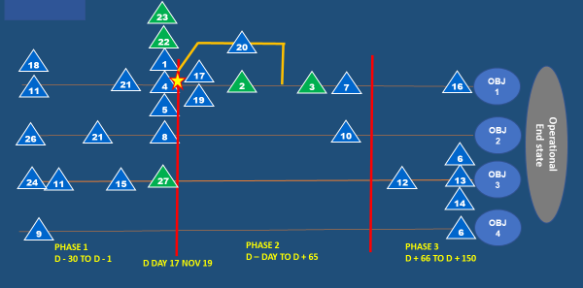

Desired Endstate:
MU AF is defeated and TEDUNG Gp neutralised. Sovereignty over Northern Malaysia is preserved. Conduct Stab Ops until Status Quo Ante is achieved.
Objectives:
(a) | (b) | (c) | (d)
Obj 1: MUSANGLAND defeated | Obj 2:  Tedung Gp neutralised | Obj 3:  Local Support gained | Obj 4:  Stabilization Op within Northern Malaysia established
DP 18 - MU AF ISR disrupted NLT D-20  DP 11 - MUSANGLAND psyop/media propaganda countered NLT D-20  DP 21 - MUSANGLAND IO effectiveness denied NLT D - 15  DP 1 - MU AF invade into Northern Malaysia denied on D Day.  DP 4 - Local Air superiority Estb NLT D Day  DP 5 - Airport n Seaport secured NLT D Day  DP 17 - Key installation protected NLT D Day  DP 19 - Territory defended NLT D Day.  DP 2 - MUSANGLAND ALOC denied NLT D+3 | DP 26 - TEDUNG Group subversive and espionage activities denied NLT D - 30  DP 21 - MUSANGLAND IO effectiveness denied NLT D - 15  DP 8 - Tedung Gp cells destabilized NLT D Day  DP 10 - Tedung Gp ideology disrupted NLT D+45 | DP 24 - Local population in the SOUTHERN MUSANGLAND influenced against MUSANGLAND and supported MALAYSIA NLT D – 30.  DP 11 - MUSANGLAND psyop/media propaganda countered NLT D-20  DP 15 - Local sp regained NLT D-5  DP 12 - Humanitarian crisis prevented NLT D+70  DP 6 - Local govt restored NLT D+90  DP 13 - Public service restored NLT D+90  DP 14 - Public Infra restored NLT D+90 | DP 9 - Key Leadership personnel protected NLT D-20  DP 27 - Regional and international communities support obtained NLT D Day  DP 6 - Local govt restored NLT D+90
(a) | (b) | (c) | (d)
DP 3 - MUSANGLAND SLOC denied NLT D+4
DP 7 - MU AF defeated NLT D+45
DP 16 - JRCN Redeployed NLT D+90
DP 22 - MUSANGLAND C2 distrupted NLT D Day.
DP 23 - CNII within Northern corridor protected from MUSANGLAND threats and exploitation NLT D - 2.
DP 20 - Enemy Key Installation destroyed NLT D+2

- Synchronization Matrix. As per Annex D. (Omitted for exercise purpose)

- Risk Management Matrix. As per Annex E.

- C2 Structure. As per Annex F.

SUBSTEP 3 – TEST COURSES OF ACTION

24. FASSD Test Table.

CRITERIA | COA 1 | COA 2
Suitability | Able to achieve end state
Feasibility | Time, Space & Means is sufficient | More assets needed  Favorable condition ie Cabinet approval
Acceptability | Acceptable but a lot of collateral damage with probable humanitarian crisis | High risk but less collateral damage and human loss for Malaysia
Sustainability  (Logistic) | Sustainable | More mil resources required
Distinguishability | Land Centric Ops supported by Air & Sea (Defensive) | Air & Sea Centric Ops (Offensive) for pre-emptive  then Land Centric Ops

STEP 4 – COURSE OF ACTION (COA) ANALYSIS

SUBSTEP 1 – PREPARE TO CONDUCT WAR GAME

25. Direct Scope. To test both own COAs with both adversary’s Most Likely and Most Dangerous COA.

26. Organise Staff. Staff of all branches are required to take part in the war game. Detailed list of staff involved is as follow:

- COS.
- J1.
- J2.
- J3.
- J4.
- J5.
- J6.
- J9.
- LEGAD.
- IO.
27. Explain Responsibilities. The list of responsibilities of staff is as per JFHQ SOP.

28. Explain Orchestration. Keynotes from COS are as follow:

- Impartiality. All staff involved must be impartial and execute this war game with integrity.

- Creditability. All data provided and used during war game must genuine with modification through the process.

- Independent. Each Own COA must be tested against adversary ML and MD COA.
29. Determine War Game Start State. All FE used are in 100% Full Mission Capable (FMC).

30. Select War Game Method. A combined war game method will be used throughout the process.

31. Select War Game Recording Method. A war game matrix will used throughout the process.

SUBSTEP 2 – CONDUCT OF WAR GAME

32. Wargame Matrix. As per Annex G.

STEP 5 – DECISION AND CONCEPT OF OPERATIONS (CONOP) DEVELOPMENT

SUBSTEP 1 – COMPARE COURSES OF ACTION (COA)

33. Numerical Technique.

CRITERIA | WEIGHTAGE (W) | COA 1 |  | COA 2
CRITERIA | WEIGHTAGE (W) | RATING (R) | W x R | RATING (R) | W x R
Achievement of Malaysia Defense strategy | 10 | 1 | 10 | 5 | 50
Achievement of joint function | 8 | 4 | 32 | 4 | 32
Lower Impact of Associated and Residual Risks | 5 | 4 | 20 | 3 | 15
Lower External and domestic political impact | 4 | 4 | 16 | 3 | 12
Sustainability | 8 | 3 | 24 | 2 | 16
Cooperation with OGD’s/NGO’s | 5 | 3 | 15 | 4 | 20
Total |  |  | 127 |  | 145
Rank |  |  | 2 |  | 1

34. Advantages & Disadvantages Analysis.

COA | ADVANTAGES | DISADVANTAGES
1 | - Not be blame by International  community  - Gain sympathy and support from  international community  - FPDA/ASEAN/CHILAND/AS support  ASEAN support  - Sufficient time for prep  - Economy of effort  - Opportunity to deescalate the tension  - ROE complied | - High attrition rate  - Vulnerable for pre-emptive strike  - Low initiative  - High casualties  - Uncertainty  - High numbers of IDP  - May prolong duration of op  - Collateral damage on public & private infra  - Northern territory being compromised  - Limited time and space  - High rebuilding cost
2 | - High initiative  - Freedom of maneuver  - Preserve MAL northern territory  - Surprise element  - Minimum casualties  - Limited Tedung gp activities  - High Moral  - Show capability  - Disrupt/destroy enemy HVT  - High possibilities to achieve objective  - Faster military solution | - Bad boy image  - Maximum collateral damage  - International pressure  - High numbers of refugees  - CHILAND/AS support reduce  - High risk strike depth  - May collapse if MU retaliate  - May loose HVA  - Upon cabinet approval  - Prolong conflict

35. COA Risk Assessment Matrix.

RISK ASSESSMENT | COA 1 | COA 2
Collateral damage | HIGH | LOW
Escalation of hostile environment | MODERATE | HIGH
Impact on natural environment | MODERATE | LOW
Humanitarian issues | HIGH | MODERATE
Loss of domestic support | LOW | LOW
Loss of international community support | LOW | HIGH
Loss of personnel | HIGH | LOW
Loss of assets | MODERATE | LOW
Rank | 2 | 1

SUBSTEP 2 – SELECT PREFERRED COA

36. Proposed COA to be Developed into CONOP. COA 2 been selected (Defeat and Stabilise).

SUBSTEP 3 – DEVELOP CONCEPT OF OPERATIONS (CONOP)

37. CONOP will be issued separately.

38. Ack.

DATO’ HJ YAZID BIN ARSHAD
Mej Jen
Chief of Staff

Annexes:

A. Decisive Points Matrix.
B. COA 1 Synchronization Matrix.
C. COA 1 Risk Management Matrix.
D. COA 2 Synchronization Matrix.
E. COA 2 Risk Management Matrix.
F. C2 Structure.
G. Wargame Recording.

